**WEEK-1 VIDEO-4 REPORT**

4) ServiceNow Branding Overview:

* Branding: applying our identity on the UI platform to shared identity, build trust and speed adoption.
* 2 guided setups:

1. ITSM guided stepup
2. ITOM guided stepup

* Service Portal:

Widget based tool allows creation, user-friendly interfaces to now platform

* UI builder:

Allows to build a functional pages by choosing library components and layouts.

HANDS-ON EXPERIMENT-1:

Changing the banner or the page of now portal.

Step 2 – Need to wait for the instance to get ready.

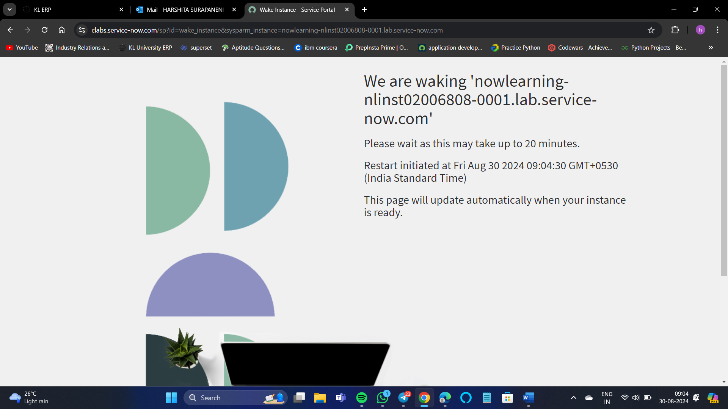

Step 3 – After logging in we can see the now platform like this,

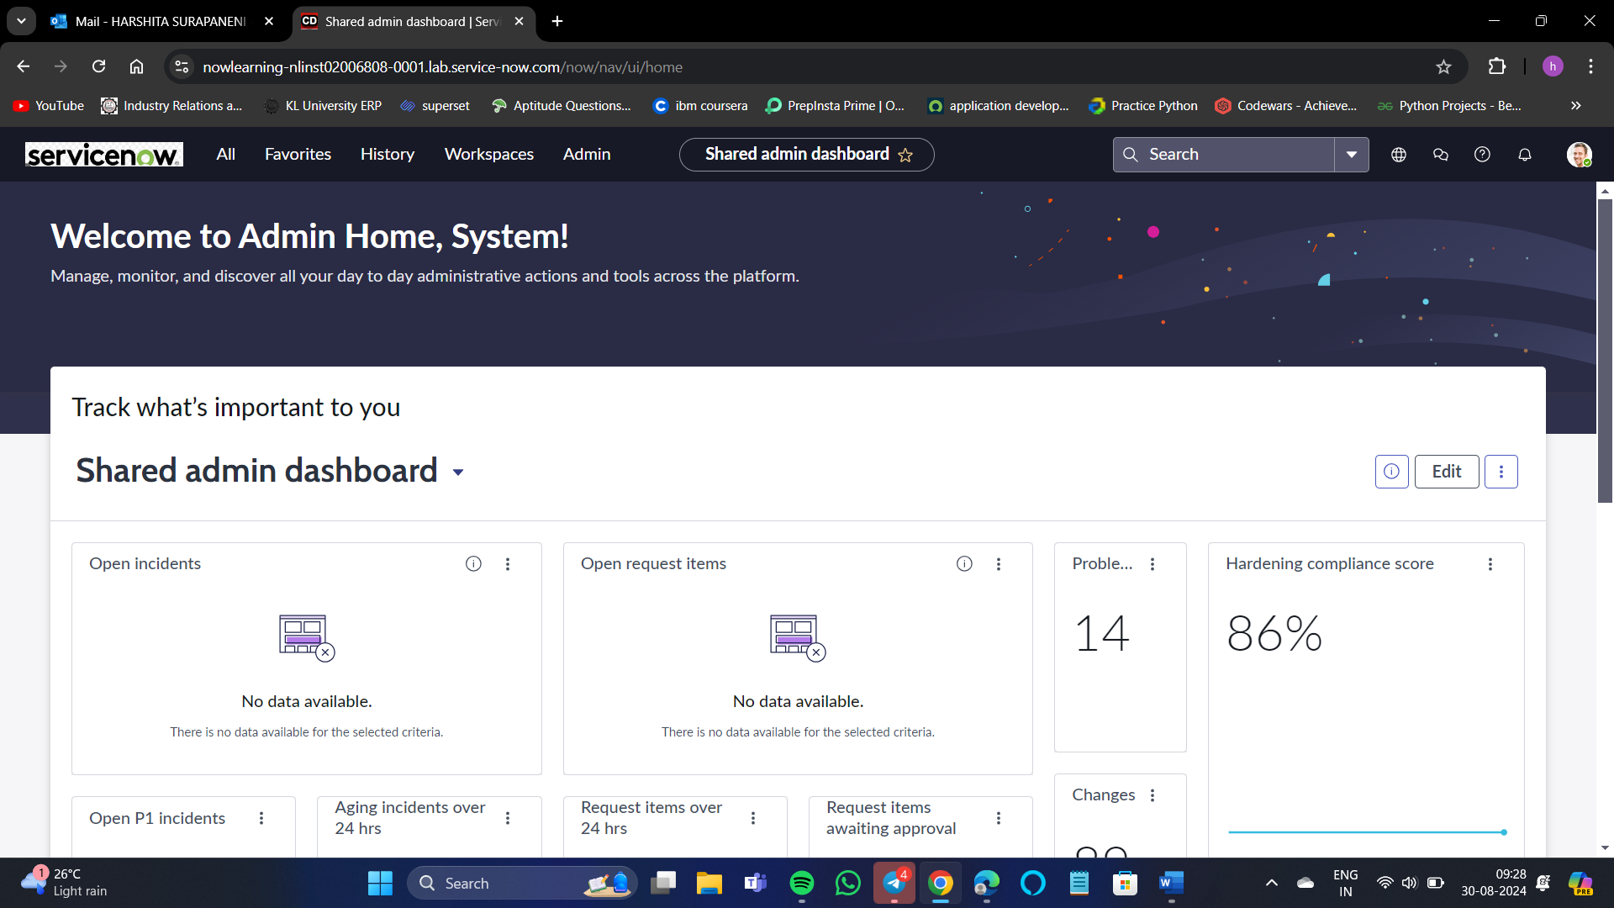

Step 4 – All -> Guided Setup -> ITSM guided setup -> Get Started -> “Company”(2 tasks) -> get started -> we need to complete the task given there -> Edit the changes(modifications) -> Save

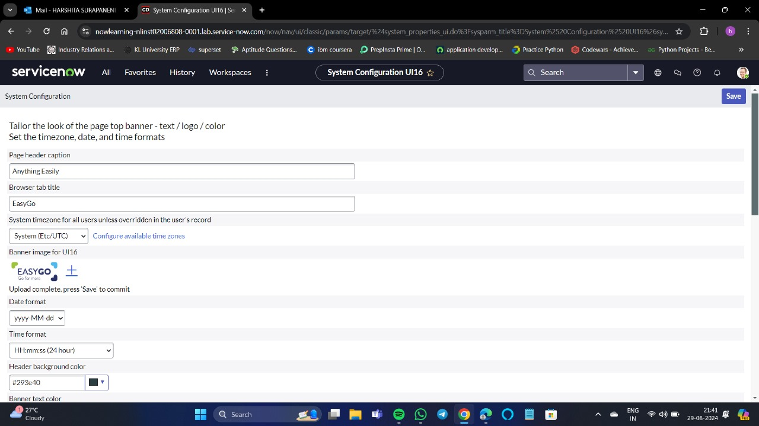

Here I have also changed the logo.

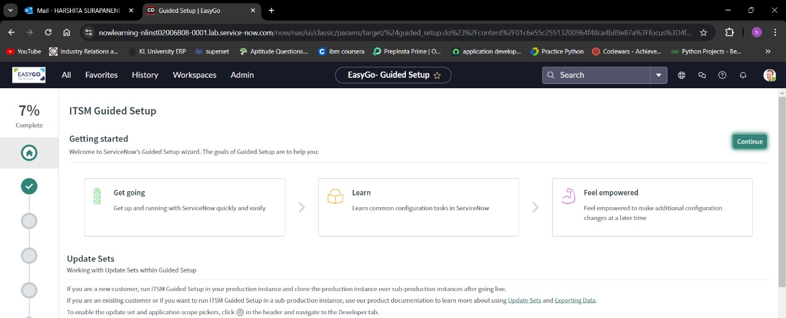

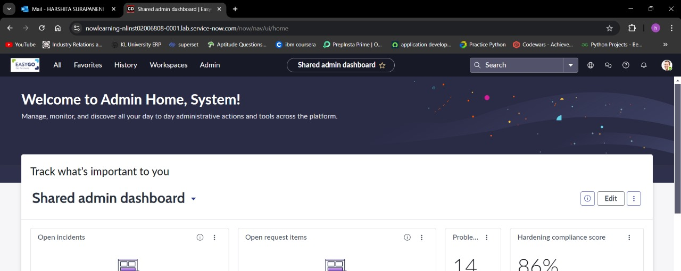Here by this process you can change the now learning platform to your company based portal.